Electrocoagulation

By using electrodes to neutralize pollutants, the electrocoagulation water treatment method effectively and sustainably cleanses water, providing the community with safe and clean drinking water.

* 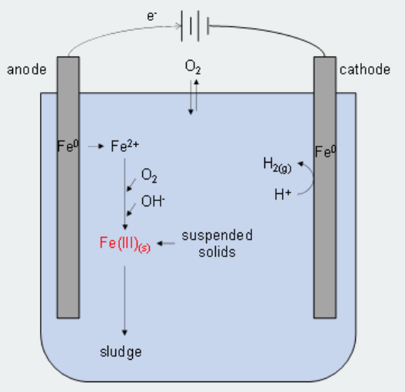Initiation of the electrocoagulation process
* Assessment of Water quality
* Electrocoagulation
* Contaminant removal
* Filtration and Separation
* Final purification
* Community distribution
* Quality monitoring

**Approaches**

* Analyse: **Analytical Testing for Contaminant Profiles**
* **Reduce: Contaminant-Specific Electrocoagulation Parameters**
* **Prevent: Source Protection and Conservation Practices**

**Technology**

Modern water treatment techniques like electrocoagulation use electrochemical processes to effectively remove a wide range of pollutants from water sources. This procedure starts in electrocoagulation cells with iron or aluminium electrodes that are powered on and cause contaminants to coagulate and flocculate. The uniform dispersion of coagulated particles is ensured by mixing equipment, and the elimination of contaminants is optimized by careful control of the reaction time. Contaminants are successfully separated after treatment using techniques such as filtering systems, flotation units, and settling tanks. The process's effectiveness is ensured by constant observation, real-time control, and close attention to residuals management as well as proactive community involvement and education. Electrocoagulation's versatility and capacity to remove multiple pollutants offer it a creative and sustainable option for tackling water quality concerns in varied contexts, boosting the accessibility of safe and clean water.

**Devices**

* **Electrocoagulation Cells or Reactors**
* **Electrodes**
* **Power Supply**
* **Mixing Equipment**
* **Sensors and Instruments**
* **Settling Tanks**
* **Filtration Systems**
* **Control Systems**